How to get a numerical breakdown of all types of inventory in the repository | 

Yoel Kortick
Senior Librarian

ONE
Navigate to the default out of the box dashboard called “Title level overlap analysis” at “/shared/Alma/Titles/Dashboards” and open it

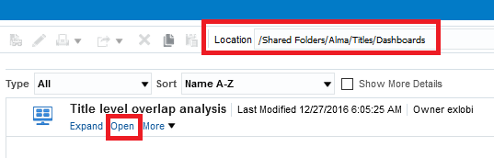

TWO
Switch to the “Inventory Breakdown” tab and see the graph and the table. This tab has all the information needed to get a numerical breakdown of all types of inventory in the repository:

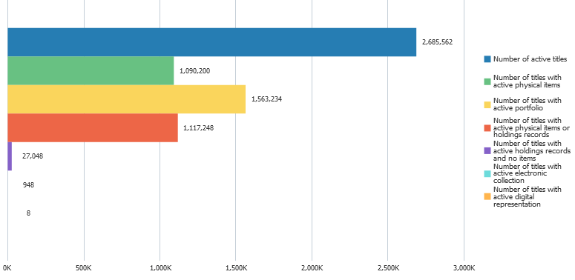

THREE
Alternatively, it is possible to directly open the report which is in the dashboard.
Navigate to “/shared/Alma/Titles/Dashboards” and open report “Inventory Breakdown”

